Interview Instructions

Before taking part in the interview, please:
- check your microphone and camera
- prepare your ID card or another photo ID

Important: Interviews are conducted:
- in Polish (if the candidate has chosen a Polish-language programme)
- in English (if the candidate has chosen an English-language programme)

Each candidate has received a separate email with a link to the interview meeting.

Meeting procedure:
- Part one – with the candidate present:
- verification of the candidate's identity by presenting an ID card or another photo ID.
- introduction of the members of the competition team.
- a verbal declaration from the candidate that their health condition allows full participation in the interview.
- presentation to the candidate of the scores awarded based on the documents submitted by the candidate in the system, in accordance with the qualification criteria, except for scores for:
- the research project
- the interview assessment.
- opportunity for the candidate to speak, including a presentation of their research project (approximately 10 minutes).
- questions from the members of the competition team and answers from the candidate
- Part two – without the candidate present:
Deliberation and determination of the score for the interview and the assessment of the research project, as well as the candidate's final score.

If the candidate does not join the meeting at the scheduled time, the meeting will proceed without their participation, and the candidate will receive 0 points for the interview assessment.

The final score awarded to the candidate, including a detailed breakdown of points for each criterion, will be visible in the candidate's account in the system on the day following the interview the latest.

The candidate is required to check the awarded score in the system no later than the day after the interview. Failure to do so does not suspend the deadline for submitting objections regarding the awarded score.

If the candidate does not see the detailed score awarded during the meeting in their system account, they should inform the chair of the Competition Committee by sending an email to: rekrutacja-edok@usz.edu.pl. In such a case, the candidate will promptly receive the score by email.

Points in the system:
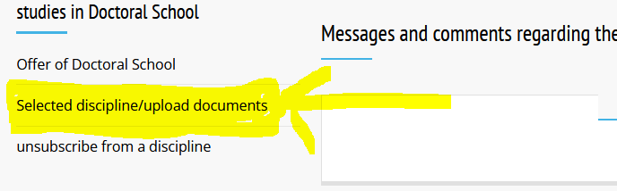
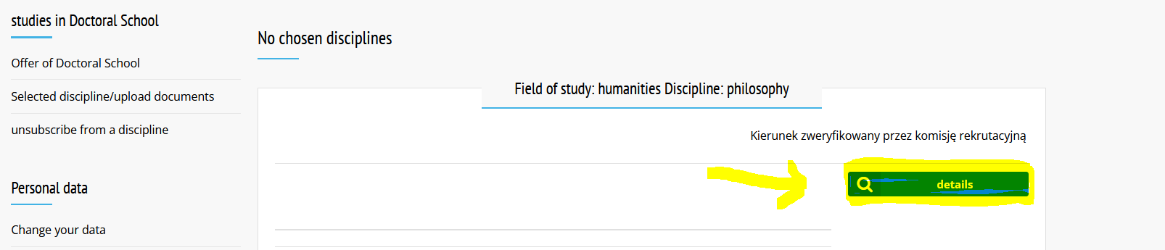

OBJECTIONS
The candidate has the right to submit a justified objection regarding the number of points awarded by the competition team within 4 days of reviewing their awarded score.

Objections must be submitted using the template available in the DOCUMENTS TO DOWNLOAD section.
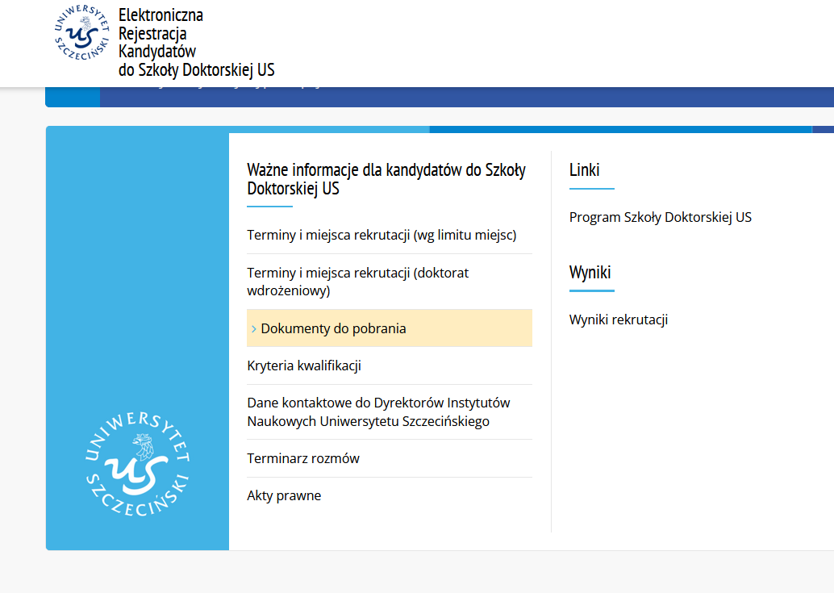
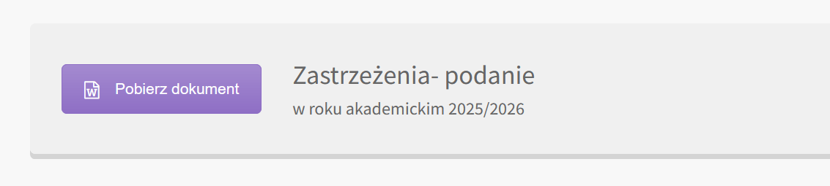
Objections, signed either with a handwritten signature (as a scan of the document) or with an electronic signature, must be sent by the candidate to the following email address: rekrutacja-edok@usz.edu.pl.

In the case of an objection being submitted, the chair of the Competition Committee appoints a new competition team composed of members who did not participate in the candidate’s previous competition procedure and sets the date of the new team’s meeting.

The candidate will be informed of the meeting date and receive a link to the meeting by email no later than 2 days before the scheduled meeting.

Important:
During the meeting held in connection with the submitted objections, the competition team re-evaluates the candidate only with regard to the criteria that are the subject of the objection.

Procedure of the meeting in connection with the submitted objections:
- verification of the candidate’s identity by presenting an ID card or another photo ID.
- introduction of the members of the competition team.
- a verbal declaration from the candidate that their health condition allows full participation in the interview.
- candidate is given the floor – they present arguments regarding the objections to the awarded points.
- questions from the members of the competition team and answers from the candidate.

Without the candidate present: Deliberation and re-awarding of points, but only with regard to the criteria that are the subject of the candidate’s objection.

