Instructions for Candidates – Admission Interview for the US Doctoral School

- Preparation before the admission interview

Before participating in the interview, the candidate should:

- Check that the microphone and camera are working.
- Prepare an ID card or another photo identification document.

Important:

- Interviews are conducted in Polish if the candidate has chosen education in Polish.
- Interviews are conducted in English if the candidate has chosen education in English.

Each candidate will receive a separate email with a link to the online meeting.

- Admission interview procedure
Part I – in the presence of the candidate

- Identity verification – the candidate presents an ID card or other photo identification upon request of the Chairperson of the competition team.
- Introduction of the competition team – team members are introduced to the candidate.
- Candidate’s statement – the candidate verbally confirms that their health allows participation in the interview.
- Presentation of preliminary scoring – based on documents submitted in the system, excluding points for the research project and the interview.
- Presentation of the candidate’s research project – approximately 10 minutes.
- Questions and answers – team members ask questions, and the candidate provides answers.

Part II – without the candidate

- The team assigns points for the research project and the interview and determines the candidate’s final score.

Note: If the candidate does not join the meeting at the scheduled time, they receive 0 points for the interview.

- Results and review of scores

- The final score and detailed information on points for individual criteria will be visible on the candidate’s ECR account on the first working day after the interview.
- The candidate is required to review the results on this date.
- In the ERK system, the points are visible after entering:
• the “Selected discipline / Upload documents” button,
• and then the “Details” button.
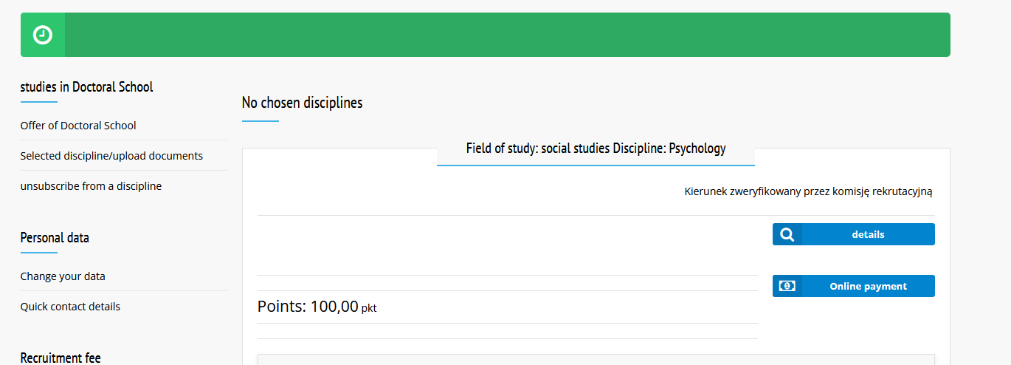
- If the scores are not visible, the candidate should immediately notify the Chairperson of the Competition Committee at: rekrutacja-edok@usz.edu.pl

- Objections to scoring

- The candidate may submit a justified objection to the points awarded in the competition procedure within 4 days from the date they reviewed the awarded points in the ECR system or – if results were received by email – from the date of receiving this information.
- Upon receiving an objection, the Chairperson of the Competition Committee appoints a new competition team different from the original one that evaluated the candidate.
- The candidate and members of the new team receive a meeting link no later than 2 days before the meeting, along with information on the new team composition.
- The new team reassigns points only for the criteria covered by the objection.
- The final score for these criteria is calculated as the arithmetic mean of the points from the first and second meetings, rounded to two decimal places.
- If the final score after considering the objection is lower than the original, the more favourable result for the candidate applies.

Note: If the objection is submitted in a language other than Polish, it must be accompanied by a Polish translation.

