 |  | 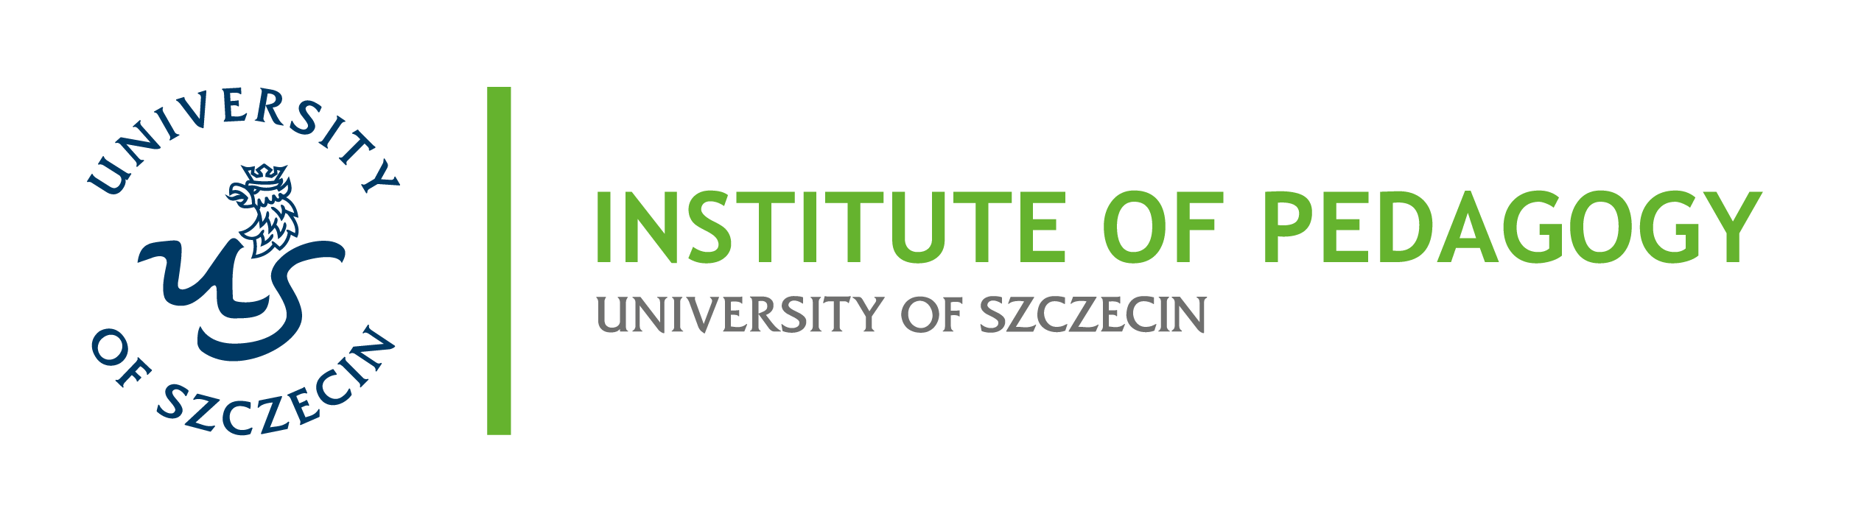
REGISTRATION FORM
Sharenting and Children’s Rights in European and East African Perspectives
International Online Scientific Conference · 20–21 November 2026 · broadcast from Szczecin
Please return the completed form by 25 October 2026 to: anita.karyn@usz.edu.pl
PARTICIPANT
Full name
Academic degree / title
Institution (affiliation)
Country
E-mail
Phone (optional)
Status | ☐ academic staff  ☐ doctoral candidate  ☐ student  ☐ teacher / practitioner  ☐ other
PARTICIPATION
Format | online – the link will be sent to registered participants (session times in EAT and CET)
Days of attendance | ☐ 20 November 2026 (Friday)  ☐ 21 November 2026 (Saturday)
Type of contribution | ☐ paper (up to 15 minutes)  ☐ poster  ☐ panel contribution  ☐ attendance without presentation
Early-career researchers’ session | ☐ yes, I am submitting my paper to the doctoral session  ☐ no
CONTRIBUTION
Title of the contribution
Co-authors (name, affiliation)
Thematic area
Keywords (3–5)

Abstract (up to 300 words, in English)

Biographical note (up to 100 words)

Technical requirements / remarks
DECLARATIONS
☐ I consent to the processing of the personal data provided in this form by the University of Szczecin and Pwani University for the purpose of organising and documenting the conference, in accordance with Regulation (EU) 2016/679 (GDPR) and, where applicable, Kenya’s Data Protection Act 2019.
☐ I acknowledge that the online sessions may be recorded; I consent to the free-of-charge recording and use of my image and presentation in materials documenting and promoting the conference and the GUARDIAN project.
☐ I consent to the publication of my abstract and biographical note in the book of abstracts.
.................................... ..........................................................
Date Signature
The data controller is the University of Szczecin, al. Papieża Jana Pawła II 22a, 70-453 Szczecin, Poland. The data will be processed solely for the purposes of the conference and of reporting within the GUARDIAN project (No. 101182798). You have the right to access, rectify and erase your data, to restrict processing, and to withdraw your consent at any time, as well as the right to lodge a complaint with the President of the Personal Data Protection Office (UODO) in Poland.
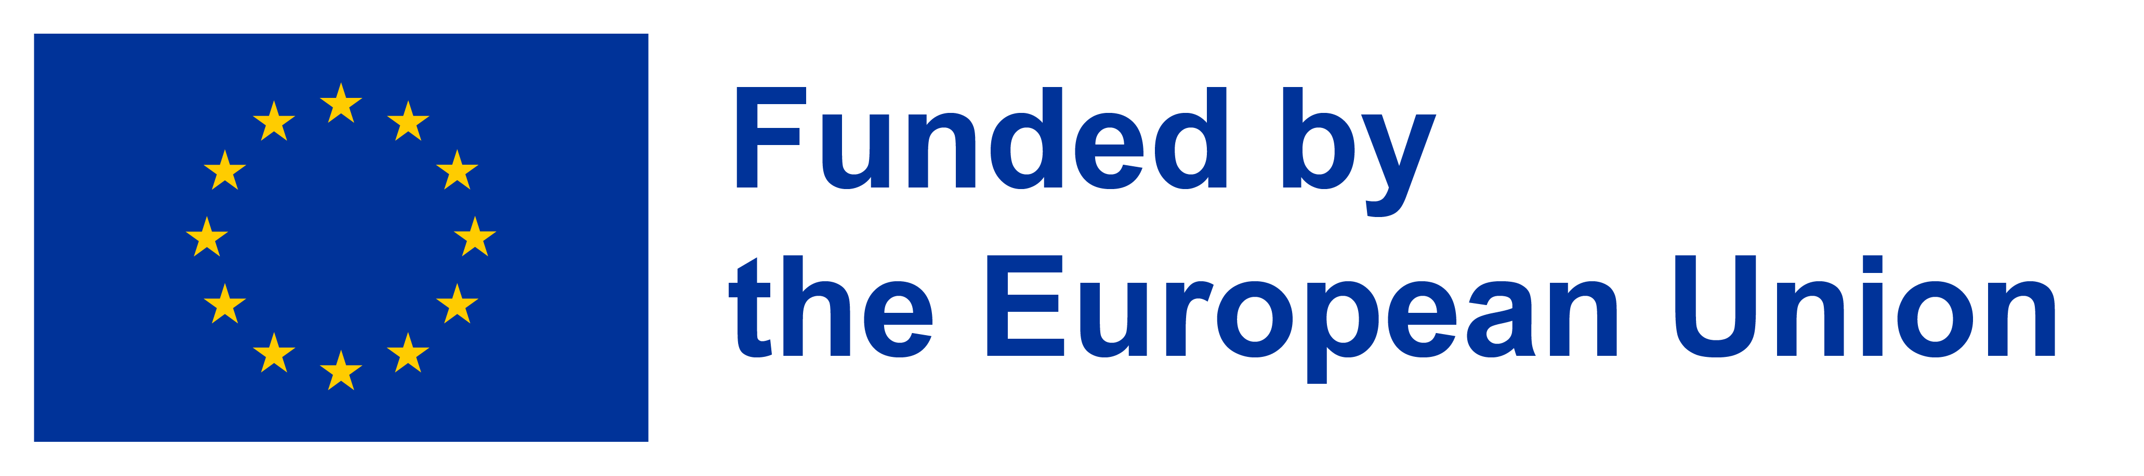
Funded by the European Union. Views and opinions expressed are however those of the author(s) only and do not necessarily reflect those of the European Union or the European Research Executive Agency (REA). Neither the European Union nor the granting authority can be held responsible for them.

